China Wireless Telecommunication Standard (CWTS);
Working Group 1 (WG1);

Physical layer Procedures
TS C105 V3.0.0 (1999-10)
Technical Specification

Contents
1 Intellectual Property Rights 2
2 Foreword 2
3 Scope 3
4 References 3
5 Definitions, symbols and abbreviations 3
5.1 Definitions 3
5.2 Symbols 3
5.3 Abbreviations 3
6 Physical layer procedures 5
6.1 General 5
6.2 Synchronisation of Node Bs and ODMA Relays 5
6.2.1 Synchronisation of Node Bs 5
6.2.2 Synchronisation of ODMA Relays (optional) 6
6.3 Transmitter Power Control 6
6.3.1 General Parameters 6
6.3.2 ODMA Power Control (optional) 6
6.3.3 Uplink Control 6
6.3.4 Downlink Control 7
6.5. Uplink Synchronisation 8
6.5.1. The establishment of uplink synchronisation 8
6.5.2. Maintenance of uplink synchronisation 8
6.5.3. The estimation of the distance between Node B and UE 8
6.6. Smart Antenna 8
6.6.1. Smart antenna structure in Node B 8
6.6.2. Beamforming 9
6.7. Cell Search Procedures 9
6.7.1 Cell Search 9
6.8 Random access procedures 10
6.8.1 Preparation of random access 10
6.8.2 Random access procedures 10
6.8.3 Random access collisioin 11
6.9 ODMA Relay Probing (optional) 11
6.9.1 Initial Mode Probing 11
6.9.2 Idle Mode Probing 11
6.9.3 Active Mode Probing 13
Annex A 14
7 History 15

1 Intellectual Property Rights
Refer to the TD-SCDMA IPR policy of CWTS.

2 Foreword
This document describes physical layer procedures for Physical Layer.
The C1 series specifies Um point for the 3G TD-SCDMA mobile system. This series defines the minimum level of specifications required for basic connections in terms of mutual connectivity and compatibility.

3 Scope
This specification describes the documents being produced by the CWTS WG1and first complete versions expected to be available by end of 1999. This specification gives also general description of the physical layer procedure of the UTRA TDD mode air interface.

4 References
References may be made to:
a) Specific versions of publications (identified by date of publication, edition number, version number, etc.), in which case, subsequent revisions to the referenced document do not apply;
- Publications without mention of a specific version, in which case the latest version applies.
[1] CWTS TS C102 (V3.0.0), “Physical channels and mapping of transport channels onto physical channels”
[2] CWTS TS C101 (V3.0.0), “Physical layer – General Description”
[3] CWTS TS C103 (V3.0.0), “Multiplexing and channel coding”
[4] CWTS TS C104 (V3.0.0), “Spreading and modulation”

5 Definitions, symbols and abbreviations

5.1 Definitions
For the purposes of the present document, the [following] terms and definitions [given in ... and the following] apply.
<defined term>: <definition>.
example: text used to clarify abstract rules by applying them literally.

5.2 Symbols
For the purposes of the present document, the following symbols apply:
<symbol> <Explanation>

5.3 Abbreviations
For the purposes of the present document, the following abbreviations apply:
BCH Broadcasting channel
BER Bit Error Rate
BS Base Station
C- Control-
CCTrCH Coded Composite Transport Channel
DC Dedicated Control (SAP)
DCA Dynamic channel allocation
DCH Dedicated Channel
DTCH Dedicated Traffic Channel
DS-CDMA Direct-Sequence Code Division Multiple Access
DwPTS Downlink Pilot Timeslot
FACH Forward Access Channel
FDD Frequency Division Duplex
FEC Forward Error Correction
FER Frame Error Rate
GC General Control (SAP)
GSM Global System for Mobile Communication
L1 Layer 1 (physical layer)
L2 Layer 2 (data link layer)
L3 Layer 3 (network layer)
LAC Link Access Control
MAC Medium Access Control
Mcps Mega Chip Per Second
Nt Notification (SAP)
ODMA Opportunity Driven Multiple Access
PC Power Control
PCH Paging Channel
PCS Personal Communications System
PHS Personal Handyphone System
PHY Physical layer
QPSK Quaternary Phase Shift Keying
RACH Random Access Channel
RF Radio Frequency
RLC Radio Link Control
RRC Radio Resource Control
SAP Service Access Point
SCH Synchronisation Channel
SIR Signal-to-Interference Ratio
TA Timing Advance
TDD Time Division Duplex
TDMA Time Division Multiple Access
TD-SCDMA Time Division Synchronous CDMA
TFCI Transport-Format Combination Indicator
U- User-
UE User Equipment
Um U interface in a mobile network
UpPTS Uplink Pilot Timeslot
UMTS Universal Mobile Telecommunications System
UTRA UMTS Terrestrial Radio Access
WCDMA Wide-band Code Division Multiple Access

6 Physical layer procedures

General
In TD-SCDMA system, more new technologies such as smart antenna, uplink synchronization, ODMA (optional), baton handover, and etc. are adopted. Most of the above mentioned technologies require the support of physical layer signalling. The related operation procedures of physical layer are reported in this section below.

6.2 Synchronisation of Node Bs and ODMA Relays

6.2.1 Synchronisation of Node Bs
In several scenarios, there is a need to synchronise Node Bs in order to optimise system capacity and to performance cell search in handover procedure. One example is a scenario for co-ordinated operation with overlapping coverage areas of the cells, i.e. there is contiguous coverage for a certain area.
Several alternatives can be used to synchronise Node Bs.
< Editors note: The specification of this Node B synchronisation protocol is for further study and depends on required synchronisation accuracy. The protocol shall fulfil the following requirements:
- Reliability and stability
- Low implementation effort
- Minimum impact on air interface traffic capacity.
For example the two (three) schemes below are considered in WG1:
- For Node B synchronisation via the air interface a special burst, the network synchronisation burst, is used. This burst is sent on a predetermined TS at regular intervals. During the reception of the network synchronisation burst in a cell the transmission in this cell has to be switched off. The Node Bs receive this burst and adjust their frame timing accordingly.
- Node Bs are synchronised by means of receiving other cells Downlink Pilot Timeslot (DwPTS).
- Syncronization information comes from RNC in Iub interface. >
- Synchronised with satellite timing system (e.g. GPS, GLONASS)

6.2.1.1 Inter-system-synchronisation
The Node B synchronization will be limited in the systems operated by one operator. Based on a master-slave structure, the network synchronization burst will be send to each Node B by the RNC when only one RNC in a local network, or be send by MSC to each RNC and then to each Node B in a larger network.
In a multiple MSC systems, the inter-system synchronisation may come from a common clock set by the operator.

6.2.1.2 Timing offset between neighbouring cells
For cell search in handover procedures, timing offset between neighbouring cells is required. The BTSs in the same cell shall transmit their DwPTS in the same time with different carrier frequency, but the BTSs in different neighbouring cells shall transmit their DwPTS at a different time separation (offset) with the same or different carrier frequency. The value of timing offset is determined in network engineering.For example, the value of timing offset can be as follows:
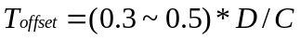 (1)
where 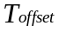is the timing offset; is the distance between the two cells; and is the speed of light.

6.2.2 Synchronisation of ODMA Relays (optional)
Due to the relatively short range of transmissions, the inclusion of ODMA does not impose any additional guard period or frame synchronisation requirements over those discussed above.
Any potential overlap caused by relay transmissions will be localised to a node and its neighbours by the ODMA protocol.
The inclusion of ODMA could relax the guard period requirements when relaying between nodes (not involving the BS) since neighbouring UEs are regarded as relay opportunities and any communications between neighbours (on an ODCH) could be synchronised further

6.3 Transmitter Power Control

6.3.1 General Parameters
Power control is applied to limit the interference level within the system thus reducing both the intracell and intercell interference level and to reduce the power consumption in the UE.

Table -1: TPC characteristics
 | Uplink | Downlink
Dynamic range | 80 dB | 30 dB
Power control rate | Variable  Closed loop: 0-200 cycles/sec.  Open loop: 1-7 slots delay | Variable  closed loop: 0-200 cycles/sec.
Step size | [1 ... 3] dB | [1 ... 3] dB
Remarks | All figures are without TPC decoding and received power measurements. | within one timeslot the powers of all active codes may be balanced to within a range of [20] dB

- All codes within one timeslot allocated to the same bearer service use the same transmission power.
- In case of one user with simultaneous RT and NRT bearer service, the closed loop power control is used both for RT and NRT bearer service. However, depending on the current services different power levels are used.

6.3.2 ODMA Power Control (optional)
<The ODMA power control is FFS>

6.3.3 Uplink Control
6.3.3.1 Common Physical Channel
The transmitter power of UE shall be calculated by the following equation:

P_{PRACH} = L_{CCPCH} + I_{BTS} + Constant value

where, P_{PRACH} : transmitter power level in dBm,
L_{CCPCH}: measured path loss in dB (transmit power is broadcasted on BCH),
I_{BTS}: interference signal power level at cell’s receiver in dBm, which is broadcasted on BCH
Constant value: This value shall be set via Layer 3 message (operator matter).

6.3.3.2 Dedicated Physical Channel
The initial transmission power is decided in a similar manner as PRACH. After the synchronisation between nodeB and UE is established, the UE transits into open-loop or closed-loop transmitter power control (TPC).
UL Open Loop Power Control:
The UE transmit power is set based on the measured path loss in the same way as for the PRACH.
UL Closed Loop Power Control:
Closed-loop TPC is based on SIR, and the TPC processing procedures aredescribed in this section. During this power control process, the nodeB periodically makes a comparison between the received SIR measurement value and the target SIR value. When the measured value is higher than the target SIR value, TPC bit =’0’. When this is lower than the target SIR value, TPC bit = ‘1’. At the UE, soft decision on the TPC bits is performed, and when it is judged as ‘0’, the mobile transmit power shall be reduced by one power control step, whereas if it is judged as ‘1’, the mobile transmit power shall be raised by one TPC step. A higher layer outer loop adjusts the target SIR. This scheme allows quality based power control.
When the TPC bit cannot be received due to out-of-synchronisation, the transmission power value shall be kept at a constant value. When SIR measurement cannot be performed for being out-of-synchronisation, the TPC bit shall always be = ‘1’ during the period of being out-of-synchronisation.

6.3.4 Downlink Control
6.3.4.1 Common Physical Channel
The primary CCPCH transmit power can be changed based on network determination. The exact power of CCPCH is signalled on the BCH on a periodic basis.

6.3.4.2 Dedicated Physical Channel
The initial transmission power of the downlink Dedicated Physical Channel is set by the network. After the initial transmission, the node B transits into SIR-based closed-loop TPC.
The measurement of received SIR shall be carried out periodically at the UE. When the measured value is higher than the target SIR value, TPC bit =’0’. When this is lower than the target SIR value, TPC bit = ‘1’. At the Node B, soft decision on the TPC bits is performed, and when it is judged as ‘0’, the transmission power shall be reduced by one step, whereas if judged as ‘1’, the transmission power shall be raised by one step.
When the TPC bit cannot be received due to out-of-synchronisation, the transmission power value shall be kept at a constant value. When SIR measurement cannot be performed due to out-of-synchronisation, the TPC bit shall always be = ‘1’ during the period of being out-of-synchronisation.

6.5. Uplink Synchronisation

6.5.1. The establishment of uplink synchronisation

6.5.1.1 Preparation of uplink sychronisation (downlink synchronisation)
When a UE is powered on, it will search the operating frequency band and try to find several strongest SYNC sequences in downlink pilot time slot DwPTS from the nearby Node Bs. After read the cell broadcast information in BCH followed by DwPTS, the UE will keep downlink synchronization with DwPTS. This period is establishment of downlink synchronisation. Only after the downlink synchronisation is established, the UE can start to establish the uplink sychronisation.

6.5.1.2 Open- and closed- loop uplink synchronisation
Although the UE can receive the downlink synchronization signal from the Node B at this moment, the distance to Node B is still uncertain which may lead unsynchronized uplink trasmission. The transmission power and timing advance used for the first transmission of the UE are set according to the received power level and the transmission power of Node B (open loop control). If the Node B detect the UE’s transmission in the searching window, it will evaluate the received the power level and timing. In the next down link time slot, the Node B will send the adjustment information to UE to modify the timing and power level for transmission and establish the uplink synchronisation procedure (closed loop control).
The establishing procedure of uplink synchronisation usually used in access procedure. It also can be used for the re-establish of the uplink synchronisation when uplink is out of synchronisation.

6.5.2. Maintenance of uplink synchronisation
The maintenance of the uplink synchronization is important in the proposed system, the midamble field in frame structure is used in each traffic channel of each main uplink time slot.
In each main uplink time slot, the midamble in each code channel is different. The BS can estimate the power level and timing shift by measuring the midamble field of each code channel in the same time slot. Then in the following downlink time slot, the BS will send the L1 control signalling of power control (PC) and Timing Advance (TA) by use of this mechanism. and then enable the UE to adjust its Tx time correctly. These procedures guarantee the reliability of the uplink synchronisation. the uplink synchronization can be checked once per TDD sub-frame. The accuracy in uplink synchronization remains in 1/2 chip duration.

6.5.3. The estimation of the distance between Node B and UE
The uplink synchronization asks the UE to transmit in advance a time shift (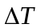), which depends upon the distance between Node B and the UE. Obviously, one may estimate the distance between Node B and the UE by use the known time shift that:
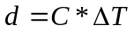 (2)
where is the speed of light.

6.6. Smart Antenna

6.6.1. Smart antenna structure in Node B
The proposed TD-SCDMA is mainly based on the smart antenna technology as described. Generally speaking, a smart antenna based Node B should be that shown in Figure 1. The smart antenna array is composed of  antenna elements, related feed cables and coherent RF transceivers in RF part. By use of the A/D converters or D/A converters in analog baseband (ABB), the Rx and Tx analog signals are interfaced to the digital baseband (DBB) part over the high-speed data bus. In this model, all antenna elements related feed cables and coherent RF transceivers will be calibrated before operating.
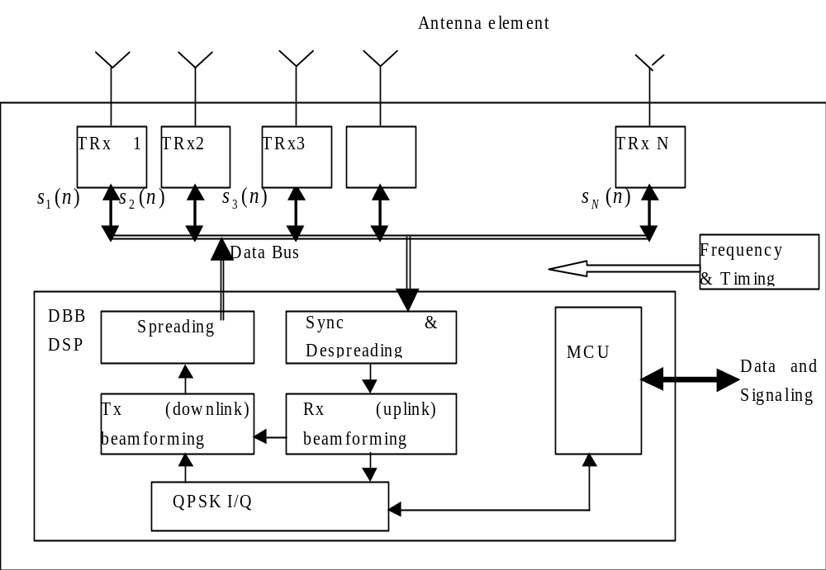
Figure 1 Block diagram of Node B with Smart Antenna

6.6.2. Beamforming
Reference to Figure 1, the Node B is equipped with smart antenna array and DBB DSP. When a signal comes from one UE within the coverage of the Node B, each antenna element and coherent RF receiver will get it. Because of the different location of the different antenna element, the phase of the Rx signal will be different. In case of multipath propagation, each path will come from different directions with different amplitude and delay. Then the Rx signal at each antenna element will show different phase and amplitude. After the front-end processing in RF part and A/D converters processing in ABB, digitized Rx signal with the phase and amplitude information will be sent to DSP in DBB part. In a CDMA cellular system, there are many UEs working simultaneously. The Rx signals will be the sum of the signals (including main path and multipath) coming from all the active UEs within the cell and the interference coming from nearby cells.
An example of the beamforming algorithm is described in Annex A.

6.7. Cell Search Procedures

6.7.1 Cell Search

During the initial cell search, the UE searches for a cell. It then determines the DwPTS, sub-frame and super-frame synchronisation of that cell and then decodes the contents in BCH. The initial cell search uses the DwPTS and BCH are described in [1].
This initial cell search is carried out in three steps:

Step 1: Search for DwPTS
During the first step of the initial cell search procedure, the UE uses the SYNC (in DwPTS) to acquire DwPTS synchronization to a cell. This is typically done with one or more matched filter (or any similar device) matched to the received SYNC which is chosen from Gold sequences set. This can be obtained by detecting peaks in the matched filter(s) output(s). The corresponding SYNC of the maximum peak is the SYNC of the strongest cell.
In order to get more reliable output on low signal-noise-ratio, the output(s) of the matched filter(s) may accumulate a few sub-frames before decision.

Step 2: Sub-frame synchronisation
During the second step of the initial cell search procedure, the UE receives the BCH, which is followed by the DwPTS Since the SYNC and the scrambling code of the BCH is relevant one by one (that is, once the SYNC is detected, the BCH scramble code can be determined), the UE can verify the correction of the BCH. According to the result of verification, UE may go to next step or go back to step 1.

Step 3: Super-frame synchronisation
During the third step of the initial cell search procedure, the UE search for the head of super-frame and get the frame number first. And then read the complete broadcast information of the found cell in one or several BCHs.

Random access procedures

Preparation of random access
When the UE is in Idle mode, it will keep the downlink synchronisation and read the cell broadcast information. From the cell broadcast information, the UE will get the code set assigned to UpPTS SYNC1 for random access, the number and position of the RACH channel, the number and position of the FACH channel, the operation mode (symmetric or asymmetric) of the cell, and other information related to random access. Also, the UE need to estimate the timing and power level for the transmission of random access bursts according to the received DwPTS from Node B.

Random access procedures
The SYNC1 sequence in UpPTS following the guard time slot is used only for uplink synchronisation; it is a known orthogonal Gold code sequence. In this period, only the UEs (maximum 8 UEs) that want to establish the uplink synchronisation will transmit with random chose Gold code sequences with the estimated timing and power
. Once the Node B detects the transmission from one UE, or has found the correlated peak value exceeding the minimum threshold, the timing advance (TA) and uplink power control (PC) could be obtained by comparing the detected arrival time and power level of the SYNC1 with the expected arrival time and power level. The Node B will response to the UE by sending its control signalling over the chosen FACH in the following subframe.
Once the UE receives the above mentioned control signalling in the chose FACH, its access request has been accepted by the Node B. Then the UE will adjust it’s timing and power level and send the RACH in the code channel corresponding to the FACH. In this step, the RACH send to Node B by UE will has high synchronisation precision.
The UE and Node B will exchange the information and packets related to access in the FACH/RACH pair mentioned above and finish the random access procedure in physical layer.

6.8.3 Random access collisioin
When a collision happened or in bad propagation environment, the Node B can’t receive SYNC1. In these case, the UE will not get any useful response from the Node B in the FACH of next subframe, thus the UE will have to adjust it’s Tx time and Tx power level based on the new SYNC and re-send the SYNC1 after a random delay.
Besides above detailed mentioned situations, all kinds of following procedures for the UE could be concluded as follows:
- If the UE has detected no answer or error answer in the control signalling packets in the FACH, it will abandon these packets. To avoid the risk of collision with other UEs, it will re-send the access request with the newly estimated Tx time and Tx power level based on new SYNC after a random delay.
- If the UE has correctly received the downlink control signalling packets in the FACH, but the in-band identification does not match, the UE will abandon these packets. To avoid the risk of collision with other UEs, it will re-send the access request with the newly estimated Tx time and Tx power level based on new SYNC after a random delay.
- If the UE has correctly received the downlink control signalling packets in the FACH, but without in-band identification, the UE will abandon these packets. To avoid the risk of collision with other UEs, it will adjust its Tx time and Tx power level as the TA and PC information informed by the Node B and re-send the access request after a random delay.
- If the access request in RACH can be correctly received by the Node B, and the response from Node B in FACH is also correctly received by the UE with the in-band identification matched, the UE understands that the Node B has accepted its access request. Then the UE will adjust its Tx time and Tx power level as the TA and PC information informed by the Node B. And it will continue its access procedures in the same RACH/FACH pair of the next subframe
If the UE can not access the Node B as the above-described procedures within the fixed period, it will turn into standby state.

6.9 ODMA Relay Probing (optional)

This section describes the probe-response procedure used by ODMA nodes to detect neighbours which may be used as relays during a call.

6.9.1 Initial Mode Probing

The initial mode probing procedure is activated by a UE when it is switched on and has no information about its surroundings. In this case the UE will synchronise with the ODMA Random Access Channel (ORACH) which is used by all UEs to receive and broadcast system routing control information and data. The UE begins a probing session by periodically broadcasting a probe packet on the ORACH. The broadcast probe includes the current neighbour list for the UE which will initially be empty. If a neighbouring UE, UEa, receives the broadcast packet it will register the UE as a neighbour and send an addressed response probe. The response probe is transmitted at random to avoid contention with other UEs and typically one response is sent for every n broadcast probes received from a particular UE.

The next time the UE transmits a broadcast probe the neighbour list will have one new entry, UEa, and an associated quality indicator (a weighted factor based on the received signal strength of the response probe). It is through this basic mechanism that each UE builds a neighbour list.

6.9.2 Idle Mode Probing

The Idle Mode Probing procedure is activated when the UE has synchronised with the ORACH but is not transmitting data. This procedure is the same as that described above after ORACH synchronisation.
The ODMA Idle Mode Probing procedure controls the rate of probing on the ORACH to reduce interference levels and regulate power consumption. The procedure is governed by a state machine, which consists of the following states: full probing, duty maintained probing, and relay prohibited. Each state defines the number of probing opportunities within one N multiframe, and a probing activity parameter K which is the ratio of probe transmission time to probe monitoring time.

Full probing
Full probing is the case where probing is allowed on every ORACH timeslot within an N multiframe. The UE_{R} will probe on the ORACH at a rate defined by the probing activity parameter K.

Duty Maintained probing
The duty maintained probing is the case where probing is allowed on M slots of an N multiframe. The UE_{R} will probe on the M ORACH slots in an N multiframe at a rate defined by the probing activity parameter K.

Relay Prohibited
In this mode the UE_{R} would cease all of its ODMA probing activities and will fall into standard operation.
The probing activity levels for given state machines are illustrated in Figure 2 for a system with an ORACH for M slots per N × 16 multiframe.
Note that the distribution of probing opportunities within a multiframe may not necessarily be consecutive and located at the beginning of a multiframe.
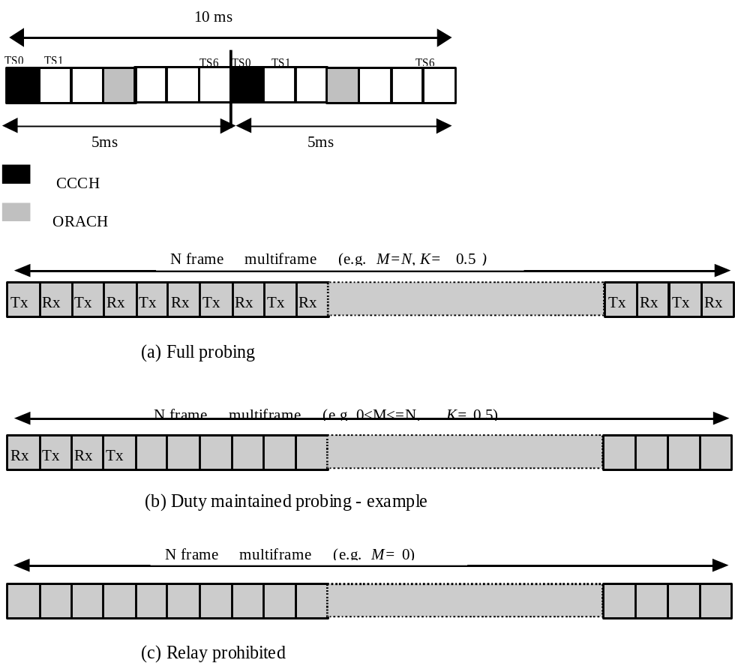
Figure 2 Probing state machines and mechanism

6.9.3 Active Mode Probing

The Active Mode Probing procedure is activated when the UE has synchronised with the ORACH and is transmitting data.
With ODMA, data may be relayed on either the ODMA Random Access Channel (ORACH) or the ODMA dedicated transport channel (ODCH), depending on the volume of data to be sent. When a UE has small amounts of data to send it may transmit an addressed probe response packet on the ORACH at an interval proportional to air interface modem rate, R_{CCH}, and is defined by Probe_timer_1. This interval also defines the broadcast probe interval, Probe_timer_2, which is typically five times longer than Probe_timer_1. Every time an UE transmits a response probe containing data on the ORACH, it may be received, but not acknowledged, by third party neighbour UEs, and provides an implicit indication of activity. In this instance broadcast probes are not necessary and Probe_timer_2 is reset after every addressed probe transmission. Only when an UE has no data to send is it necessary to transmit a broadcast probe every Probe_timer_2 seconds to register its active status with its neighbours.

In order to avoid overlapping packet transmissions the length of the packet may not exceed the probe timer interval, Probe_timer_1. The relationship between the different probe timers is illustrated in Figure 3.

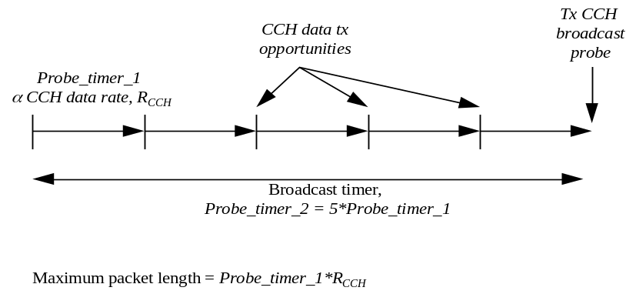
Figure 3 Probe timer relationships

Annex A
In Annex A, the following is an example of one beamforming algorithm.

Let the output of the -th receiver be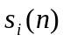 at the time . After despreading, one may obtain the Rx data of each code channel as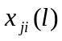 for the -th symbol, where means the-th code channel. The purpose of smart antenna in uplink is to find the best 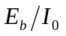 after the combination, The signal of the -th symbol in the-th code channel is denoted as 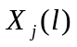, then
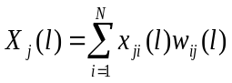 (A-1)
where  is the uplink beamforming matrix with element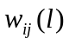.
Many beamforming algorithms can be found in published papers. Theoretically, the uplink beamforming can add up all useful signals while cancelling all multipath interference.
Next step in smart antenna is to realize downlink beamforming. The Tx signal of the -th code channel is denoted as 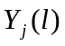 for the -th symbol. Let the UE obtain the best , then it can be obtained that
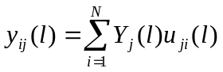 (4)
where
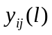is the Tx signal on the -th antenna for the -th symbol in the -th code channel;
 is the downlink beamforming matrix with element 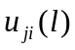.
In TD-SCDMA system, the uplink and downlink are operated at the same frequency but in different time slots. This make it possible to directly use the uplink beamforming results ( in equation (A-1)) to downlink beamforming ( in equation (4)) because of the symmetrical performance in wave propagation. The reciprocal principle in electro-magnetic theory provides the theoretical foundation.

7 History
Document history
V1.0.0 | 1999-05-28 | Document created based on TD-SCDMA RTT
V1.0.1 | 1999-06-20 | Changes after discussion with Siemens
V1.1.0 | 1999-07-30 | Version send to WG1, Ad Hoc1 for discussion
V 1.1.1 | 1999-08-03 | Version modified according to physical layer defination
V1.2.0 | 1999-08-05 | Version based on CWTS WG1 Ad Hoc1 #2 discussion in cupt (Aug5-7,1999)
V2.0.0 | 1999-08-30 | Updated in the CWTS WG1 Ad Hoc1 #3 meeting in beijing (Aug29-30,1999)
V2.0.1 | 1999-9-16 | Text modification only
V2.1.0 | 1999-10-2 | Chip rate change to 1.28Mcps
V3.0.0 | 1999-10-14 | Document accepted by CWTS WG1 Ad Hoc1 #4 and CWTS WG1 #5 in Beijing
Editor for this parts, is:

Mr. Guiliang Yang,
Email: yanggl@pub.tdscdma.com
This document is written in Microsoft Word 7.0.

